I
n this session we will look at what is Parallel gateway and how it functions ?.
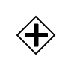
- A Parallel Gateway or AND Gateway is used to synchronize (combine) parallel flows and to create parallel flows
- A Parallel Gateway creates parallel paths without checking any conditions; each outgoing Sequence Flow receives a token upon execution of this Gateway
- For incoming flows, the Parallel Gateway will wait for all incoming flows before triggering the flow through its outgoing Sequence Flows

Camunda Parallel Gateway

- We will model below process to demonstrate use of parallel gateways.

HR Desk, will fill up candidate information from resume and complete the task. As we parallel gateway is used it will create Technical Interview 1 and Technical Interview 2 will be created at the same time. Once these interviews are completed then Manager Desk task is created with all the information of candidate and technical interviews evaluation.

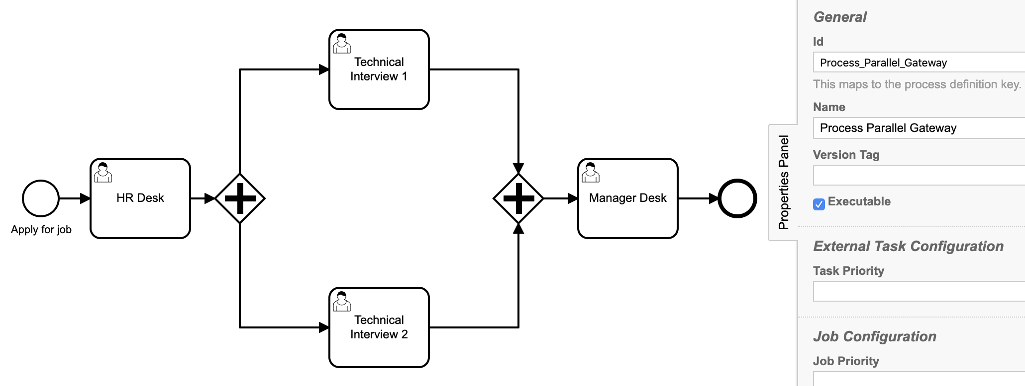
Id: Process_Parallel_Gateway
Name: Process Parallel Gateway

2. Start event: Apply for job
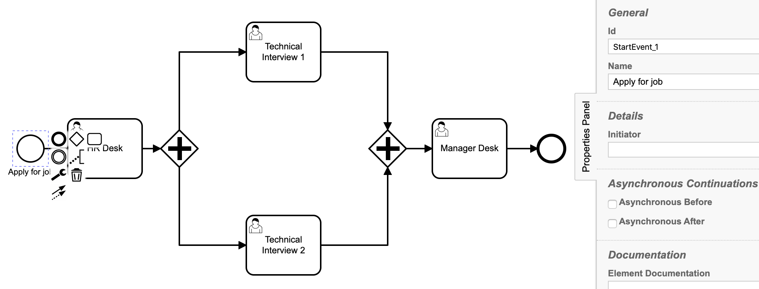
Form fields for start event and user tasks properties are same as

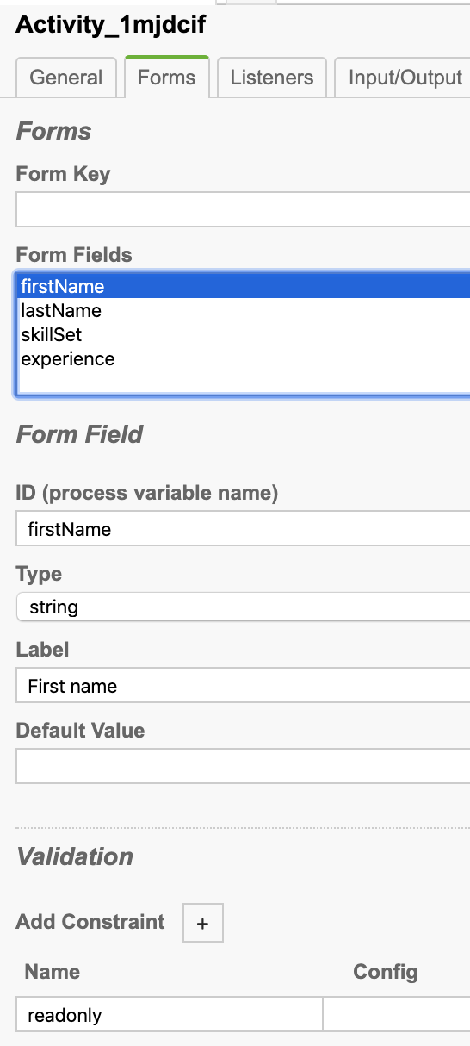
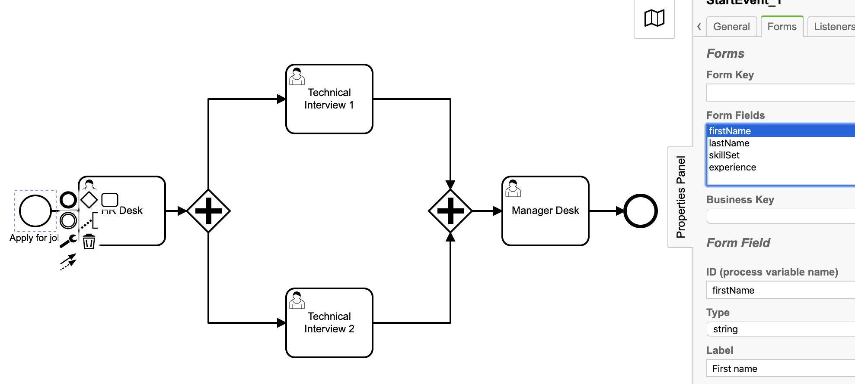
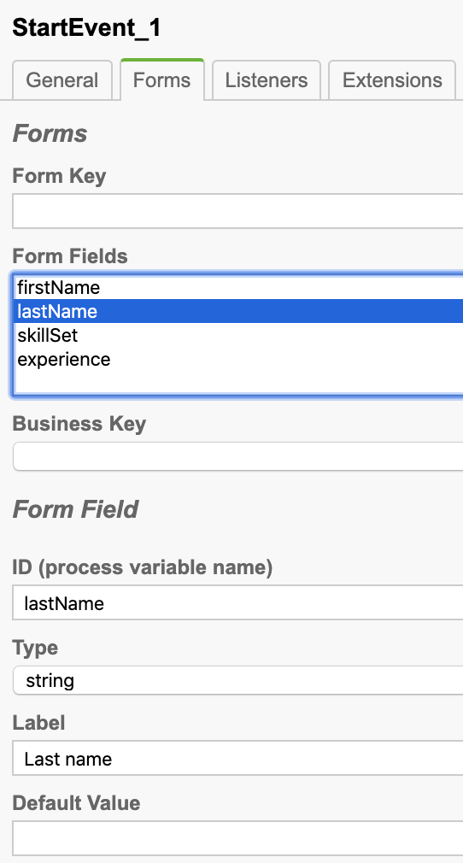
Task forms:

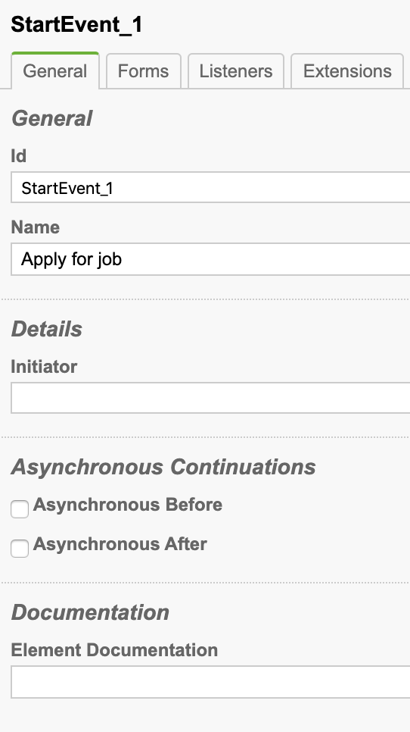

3. User task: HR Desk
Properties:
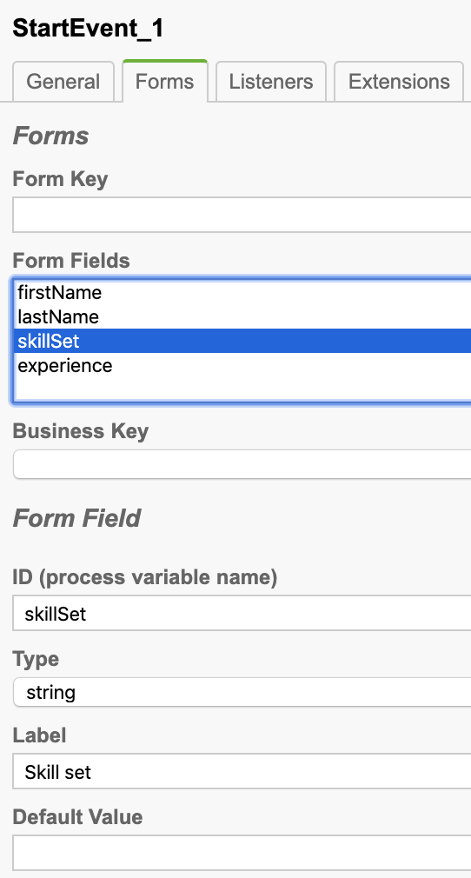
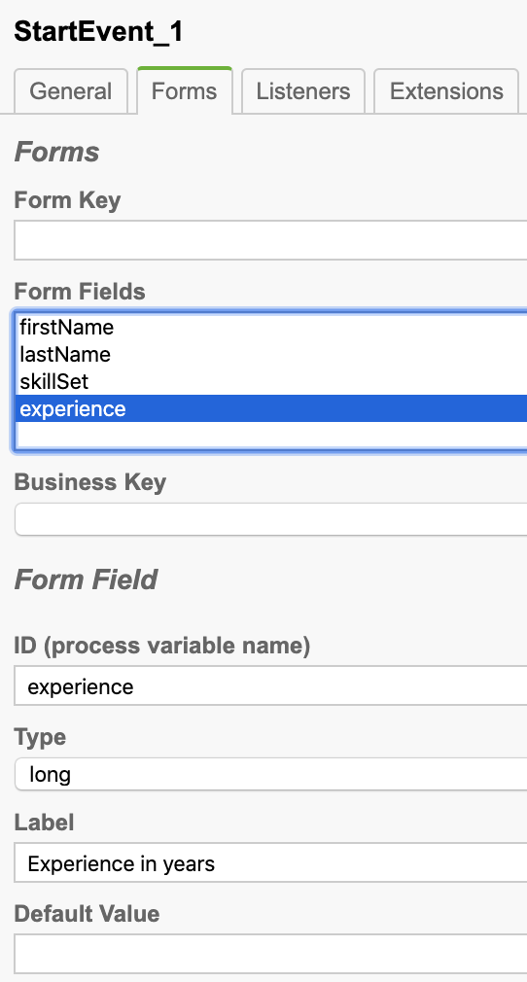
Id: Activity_1mjdcif
Name: HR Desk
Assignee: demo
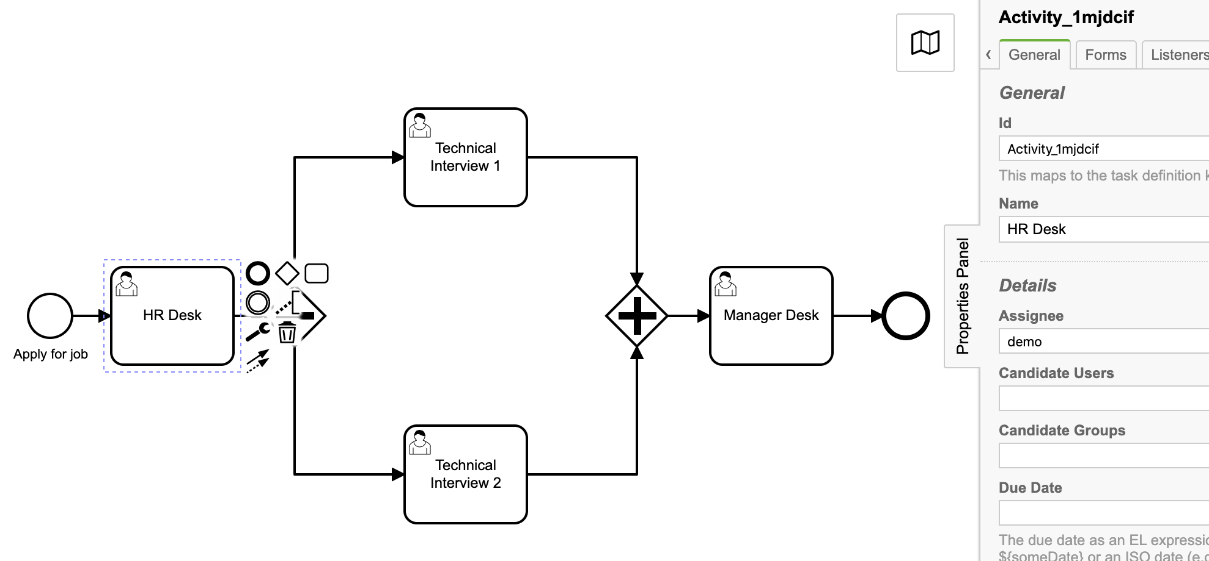


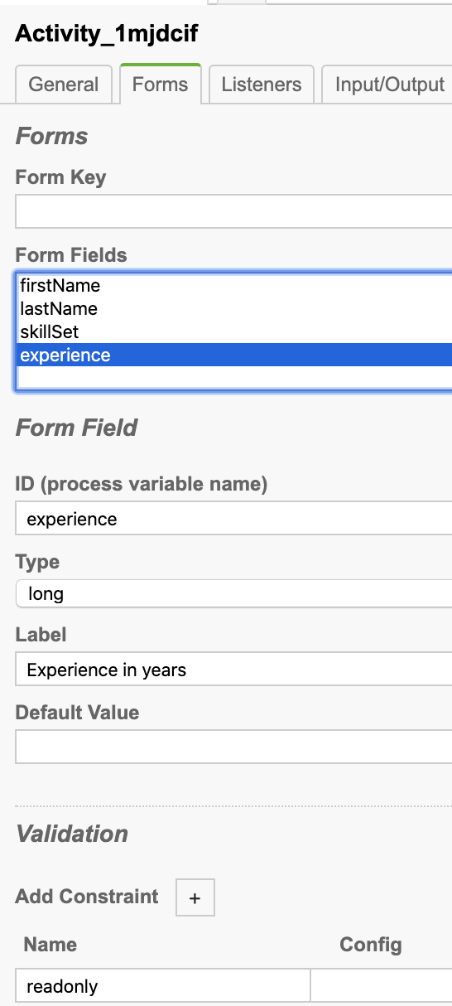
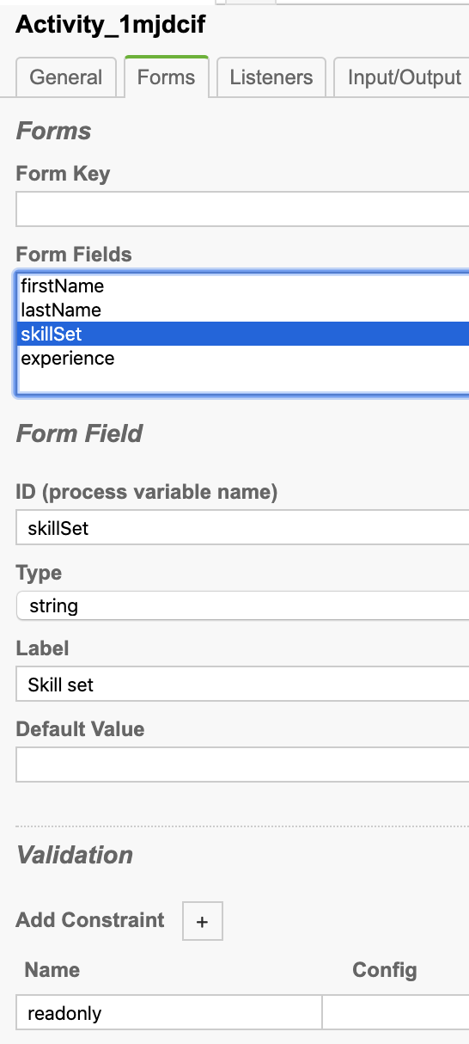
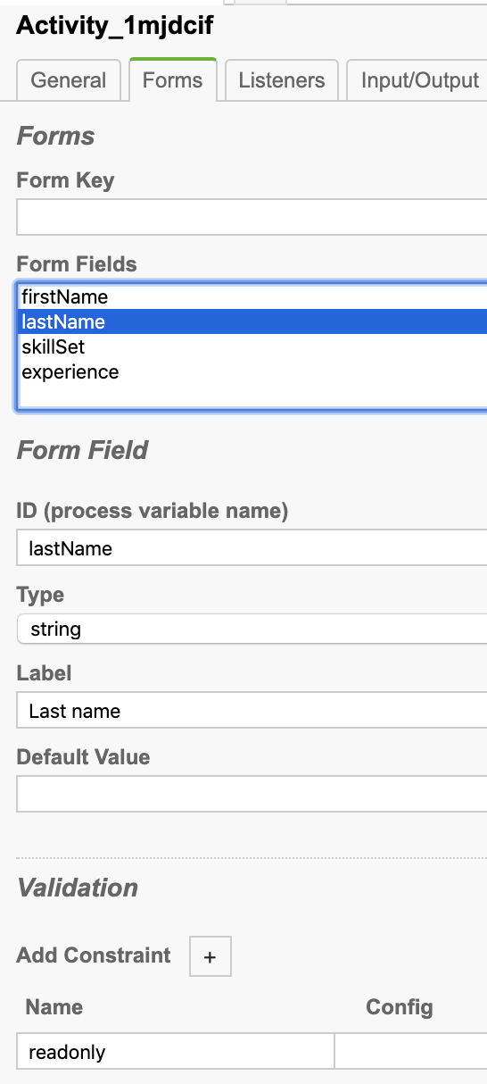
Task form:

4. User task: Technical Interview 1

Id: Activity_1k1s7cr
Name: Technical Interview 1
Assignee: demo

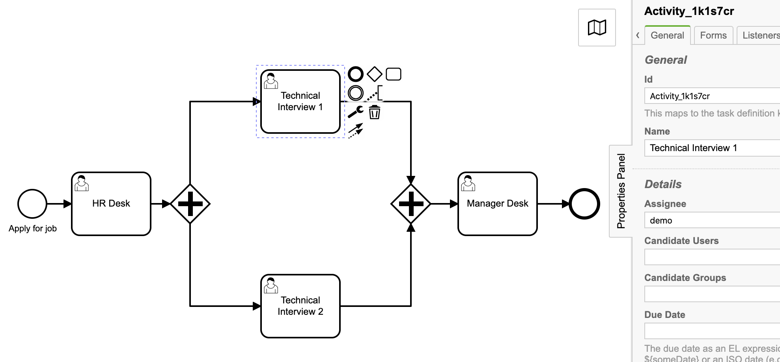

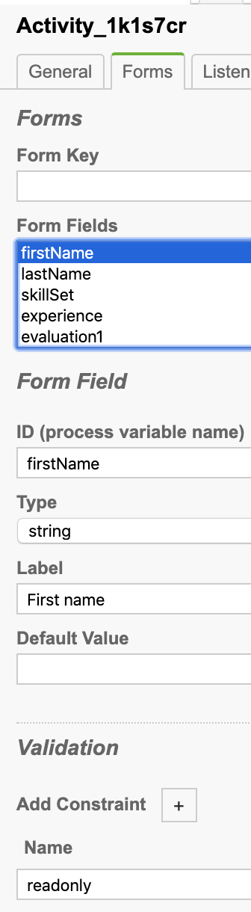
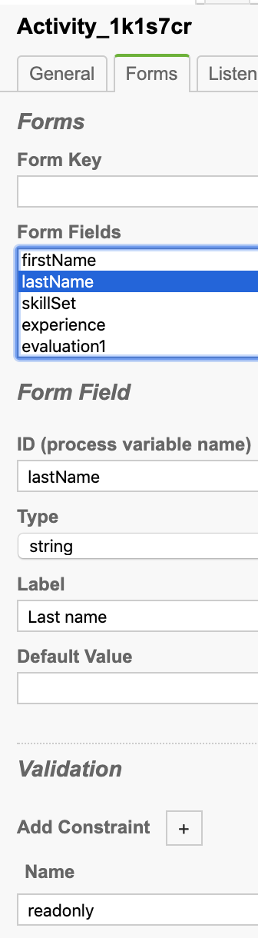
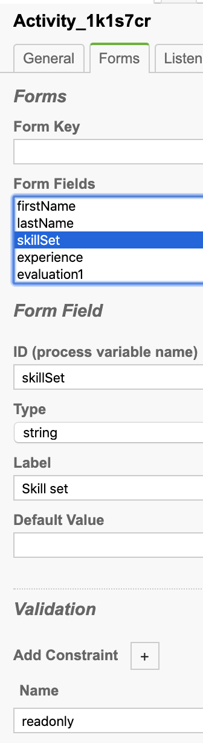
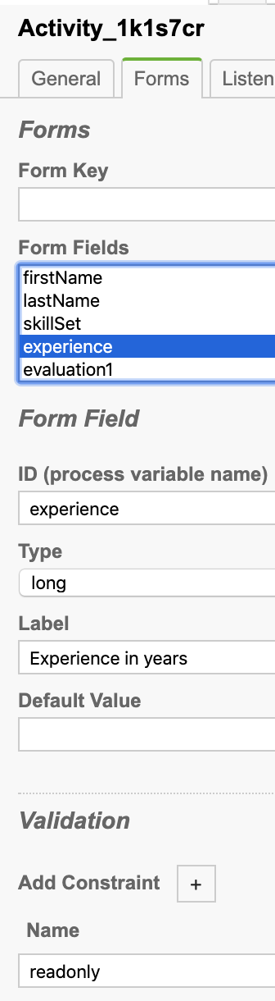
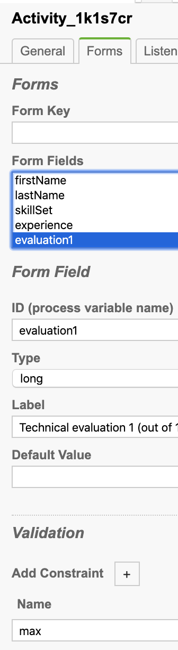
Task form:

5. User task: Technical Interview 2
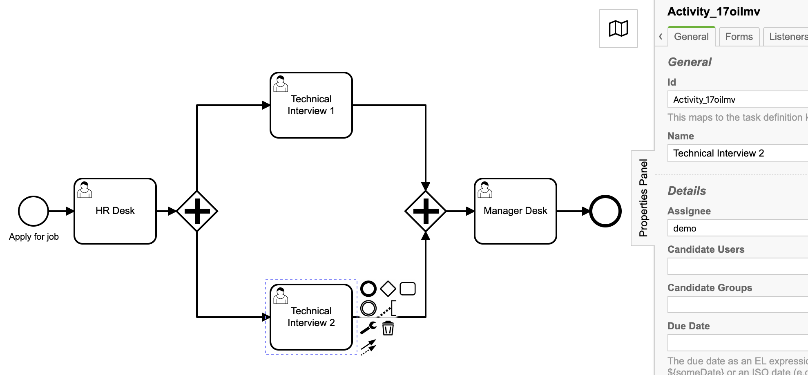
Id: Activity_11ffnq3
Name: Technical Interview 2
Assignee: demo

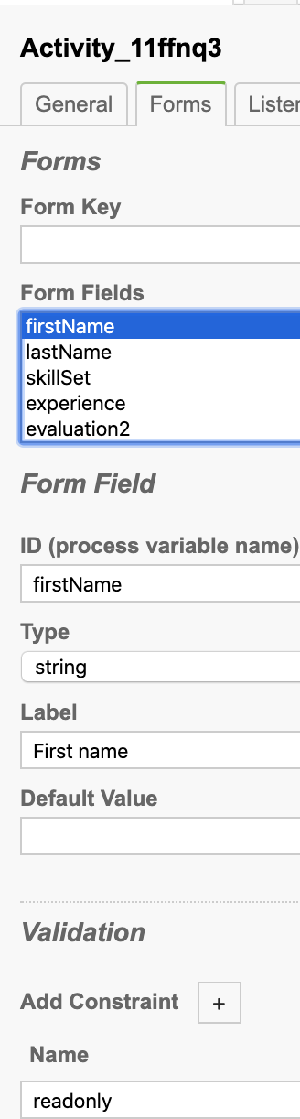
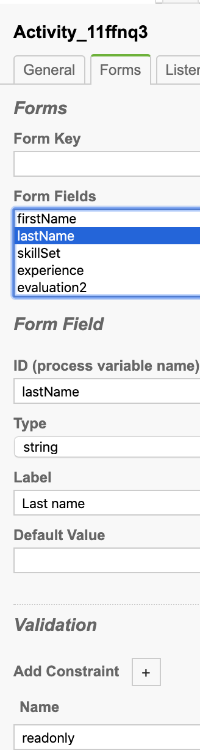
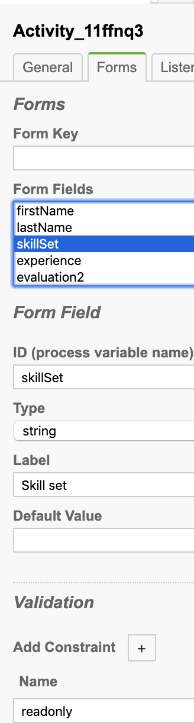
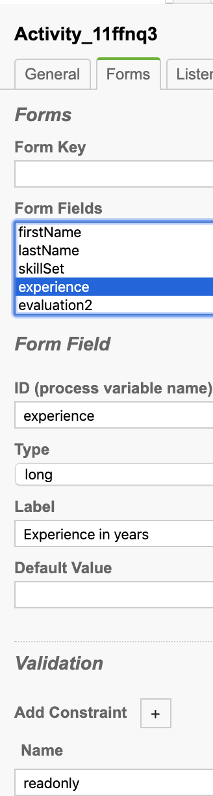
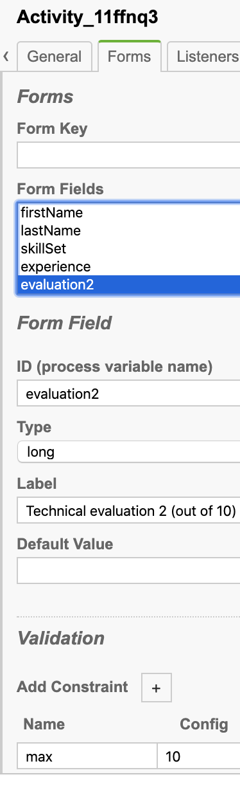
Task form:

6. User task: Manager Desk
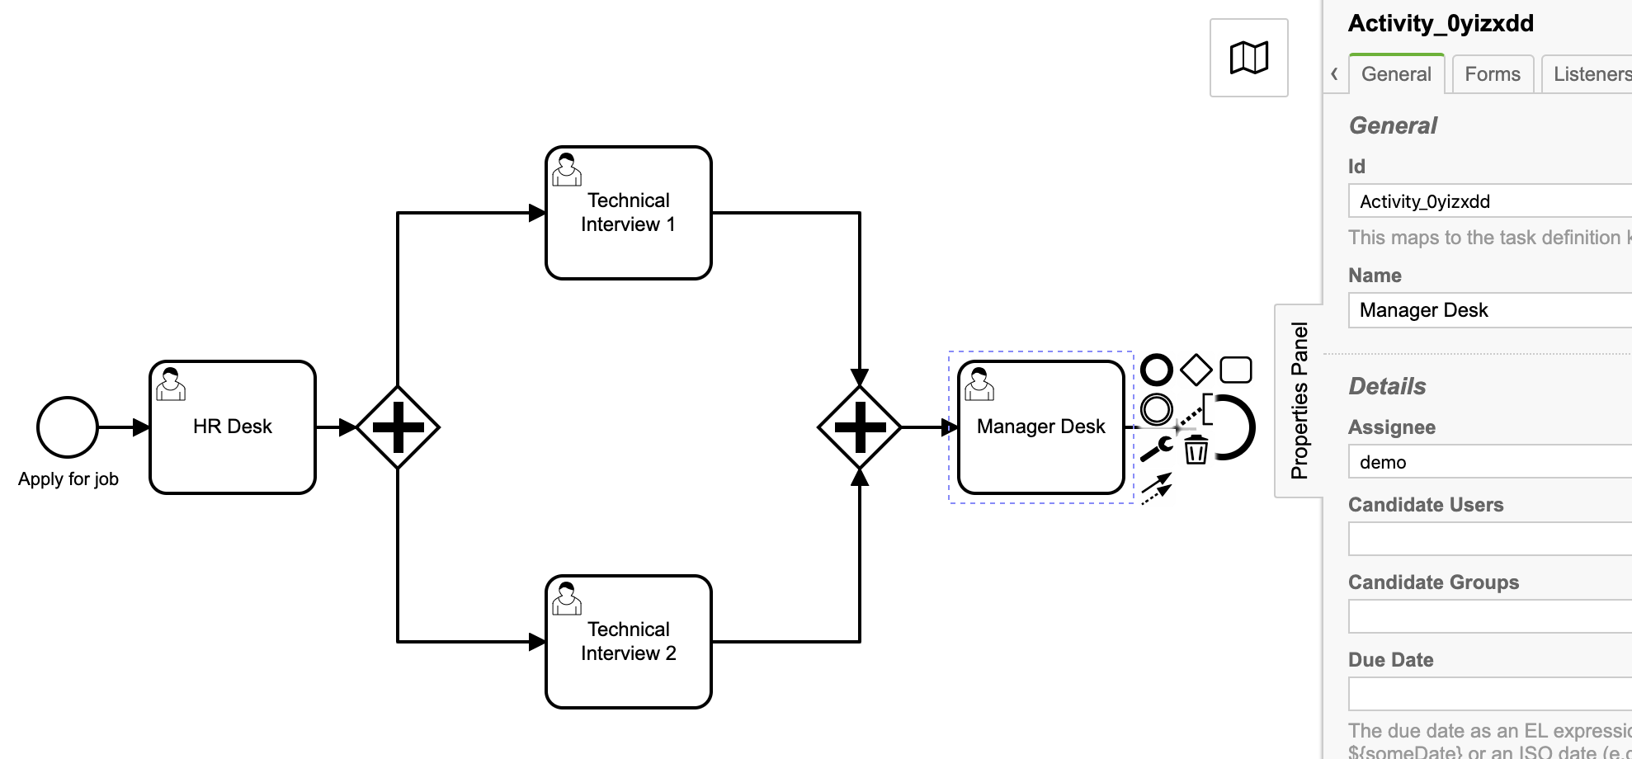

Id: Activity_0yizxdd
Name: Manager Desk
Assignee: demo

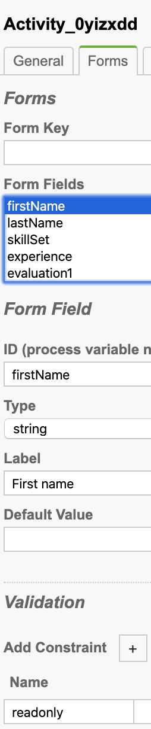
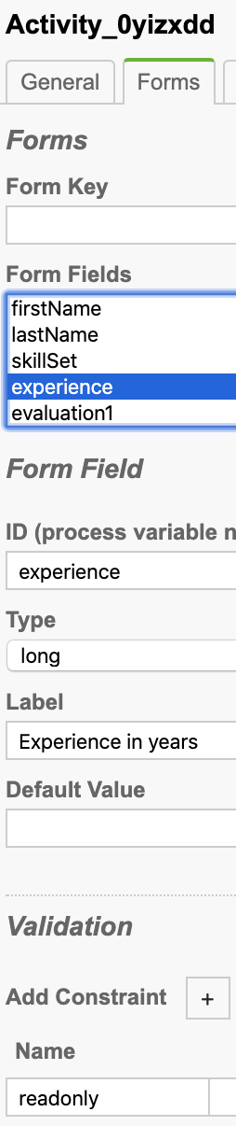
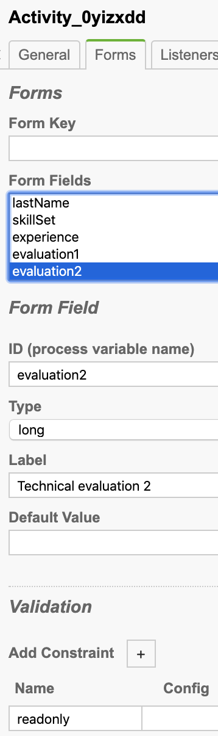
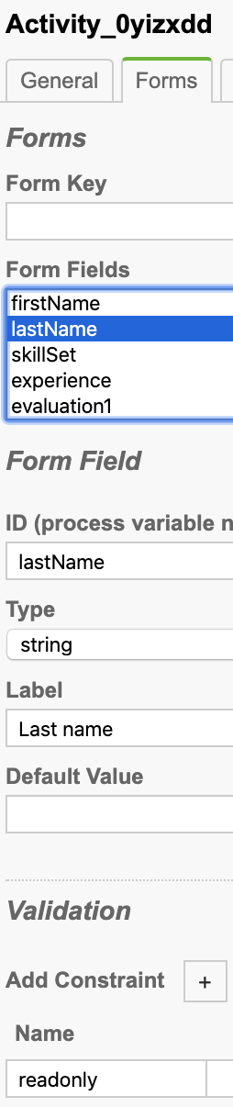
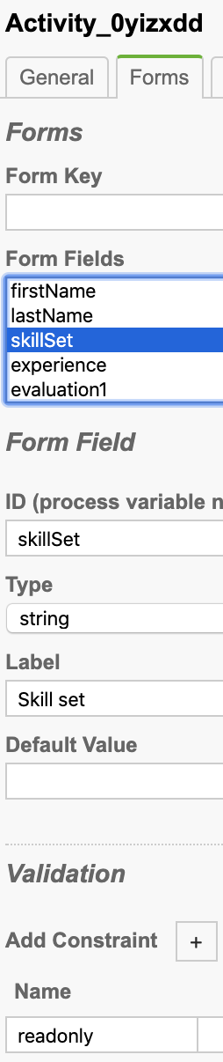
Task form:
7. Deploy the process and start the process.
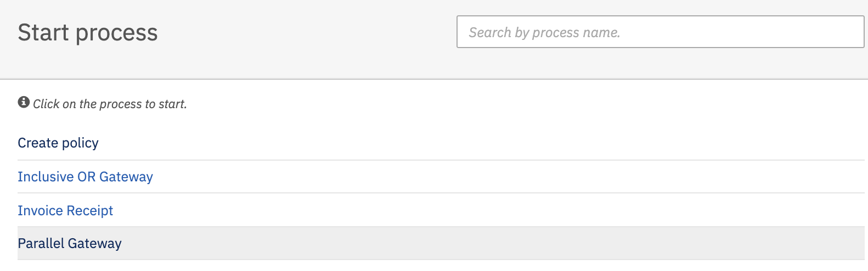

Hit the Parallel Gateway process. It will open start process form.
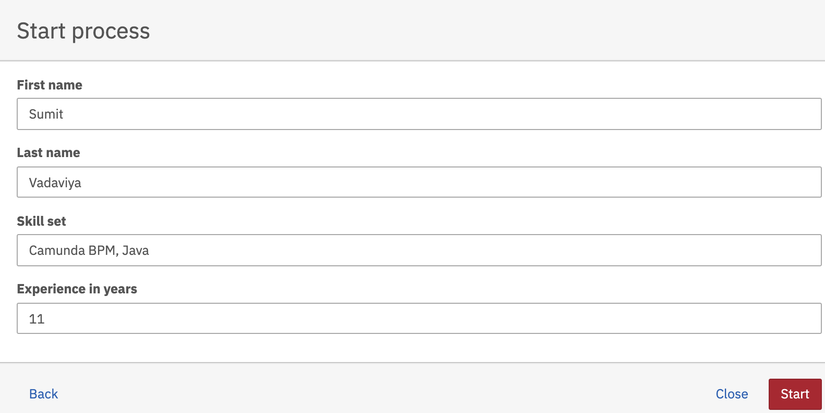

Hit the Start button.

As per process definition HR Desk user task will get created.
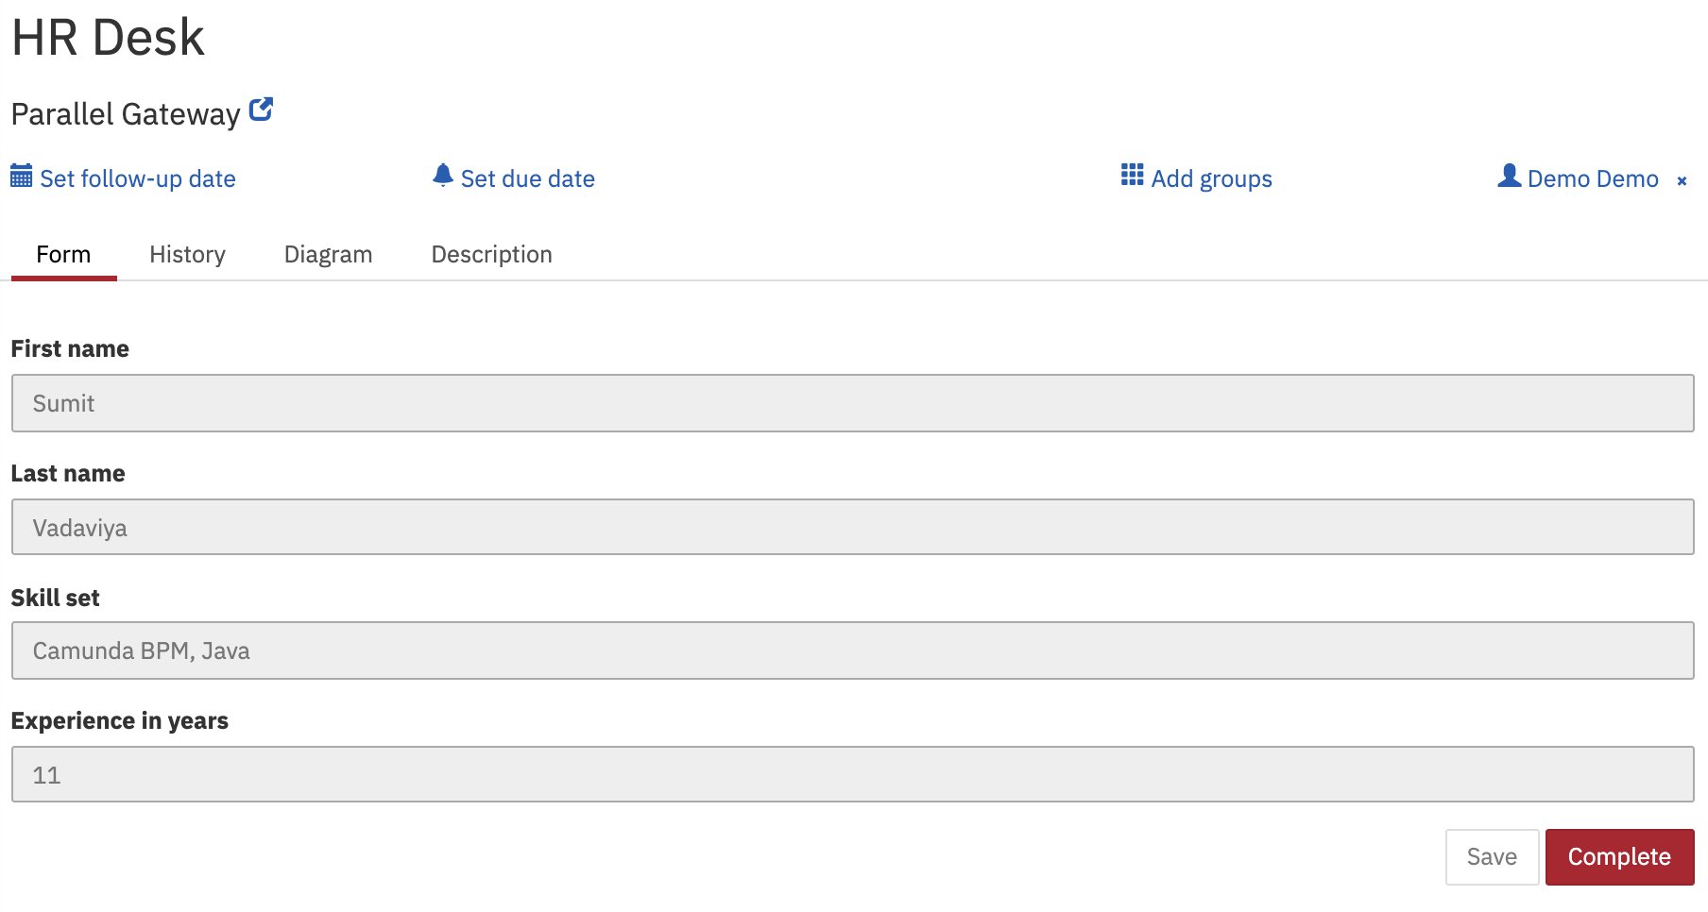

Hit the Complete button.

As we have used parallel gateways after HR Desk user task. Two user tasks Technical Interview 1 and Technical Interview 2 are created concurrently.

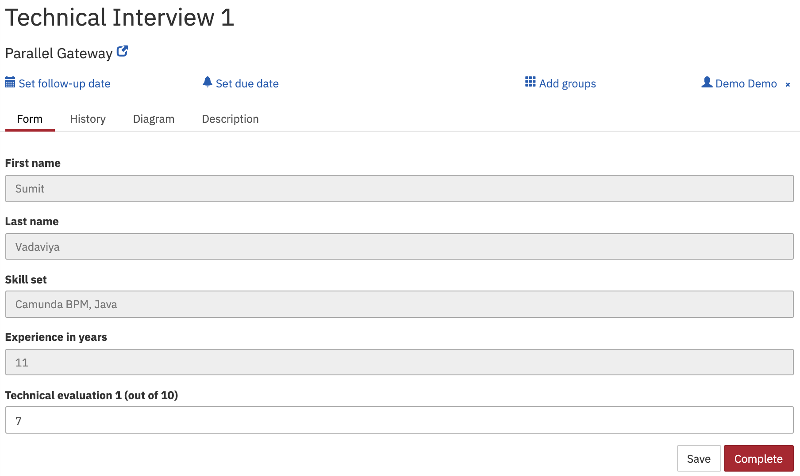
Complete the user task Technical Interview 1.
Hit the Complete button to complete the user task Technical Interview 1.
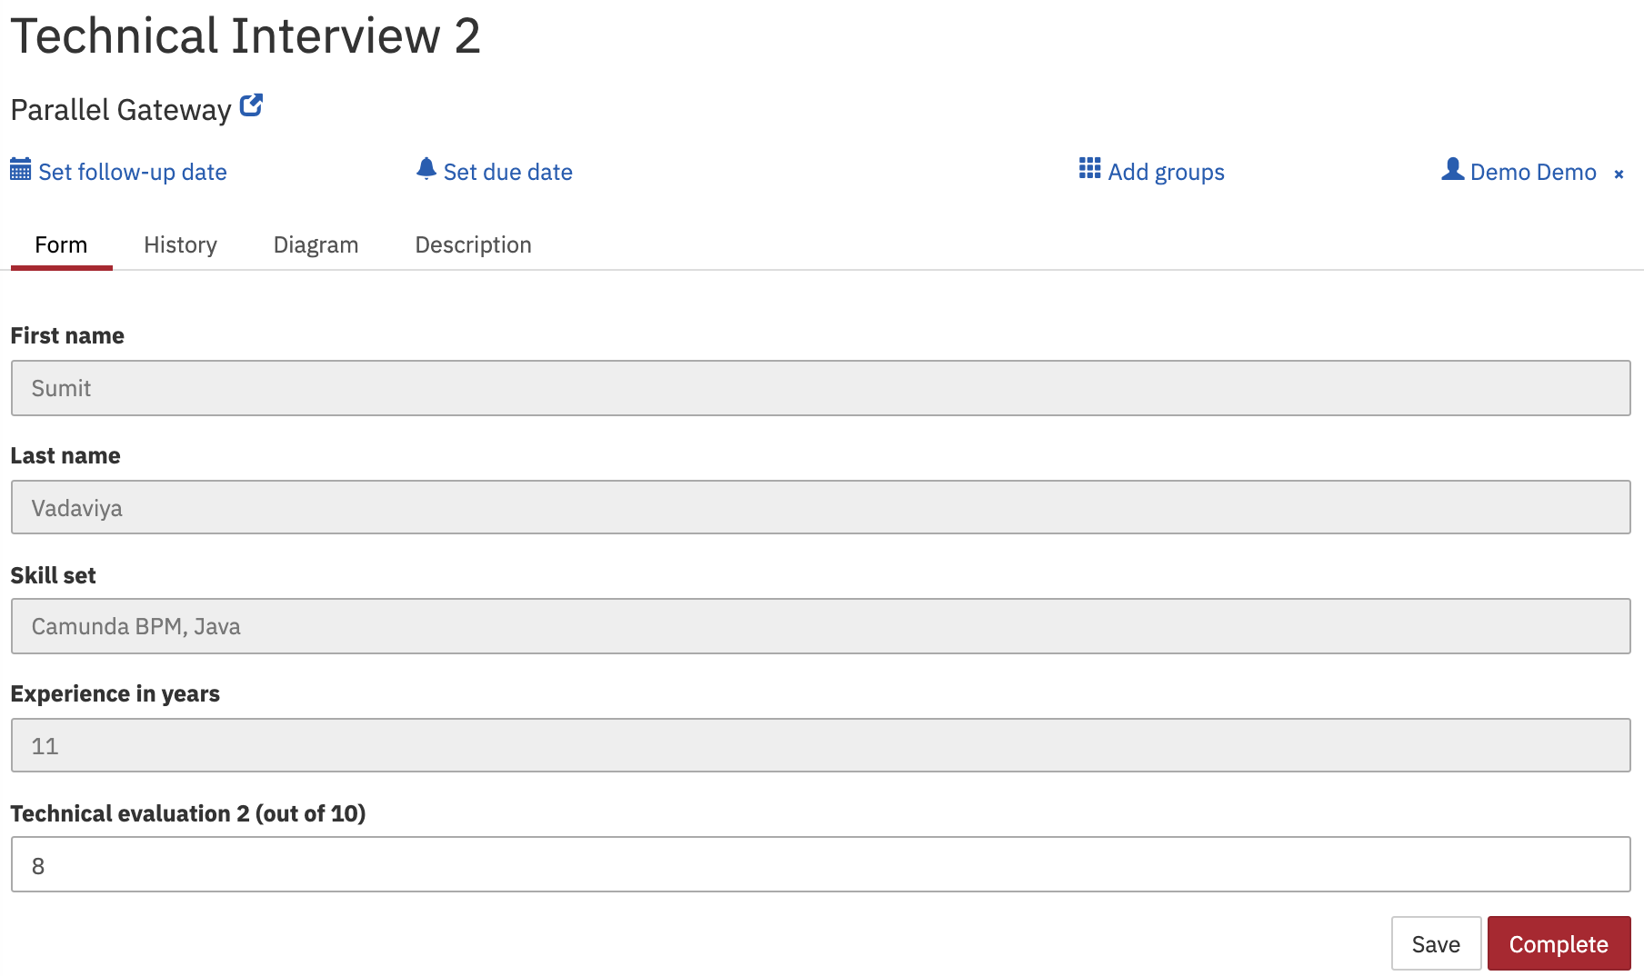
Complete the user task Technical Interview 2.

Hit the Complete button to complete the user task Technical Interview 2.

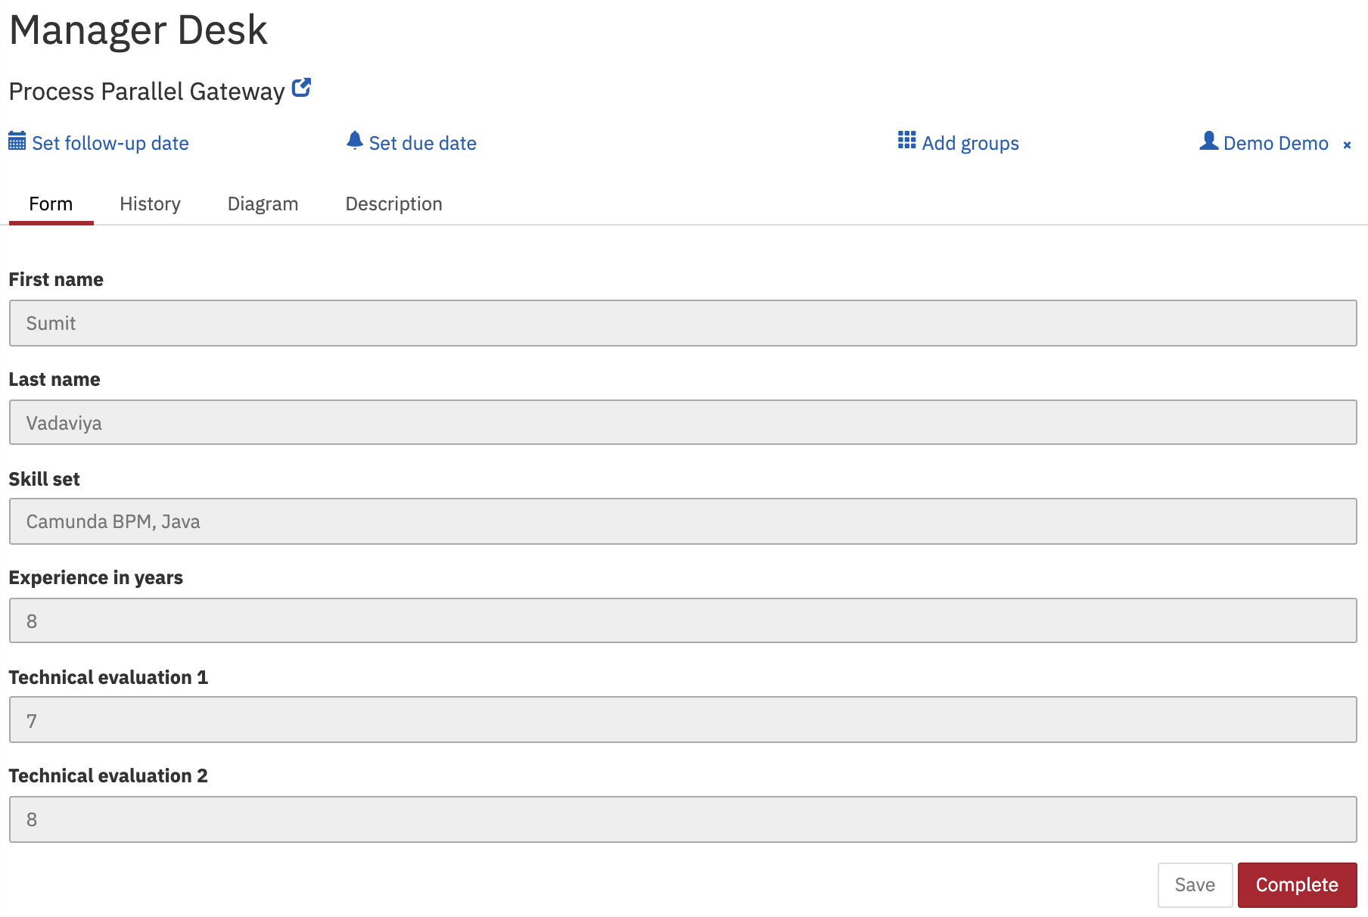
As per process definition, user task Manager Desk task will be created only after completing user task Technical Interview 1 and user task Technical Interview 2.

As you can see manager will see technical evaluations provided by previous tasks and finally hit the Complete button to stop the process.

